Arrays
15-3-26
Aim – Demonstrate Arrays(list) in python.
Theory – Arrays in Python are commonly implemented using lists to store multiple values in a single variable. Lists allow accessing elements using indexes, modifying values, adding new elements with methods like append(), and removing elements. They are dynamic, ordered, and support iteration, making them useful for storing and managing collections of data.
A1.
# Creating an array (list) of integers
numbers = [10, 20, 30, 40, 50]

# Accessing elements
print("First element:", numbers[0])
print("Last element:", numbers[-1])

# Modifying an element
numbers[2] = 35
print("Modified array:", numbers)

# Adding elements
numbers.append(60)
print("After appending 60:", numbers)

# Removing elements
numbers.remove(20)
print("After removing 20:", numbers)

# Iterating through the array
print("All elements:")
for num in numbers:
print(num)
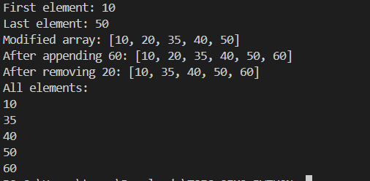

Conclusion
Python lists provide a flexible way to store and manipulate multiple values, allowing easy access, updates, additions, deletions, and iteration within programs.

